

UNIT:ETHICAL HACKING
NAME: EUGINE KIPCHIRCHIR
ADM NO: BSCCS/2024/53845
COURSE: BACHELOR OF SCIENCE IN INFORMATION TECHNOLOGY
DEPARTMENT: COMPUTING AND INFORMATICS

LECTURER : MICHAEL NYORO
SUBMISSION DATE: 4/6/2026

TASK 1.
Kalilinux on Oracle virtual box running


FootPrinting
1.whois look up
Testing site: scanme.nmap.org(made for learning)hence its safe target.I will be using my own router IP and my Windows host(Virtual box host only IP)
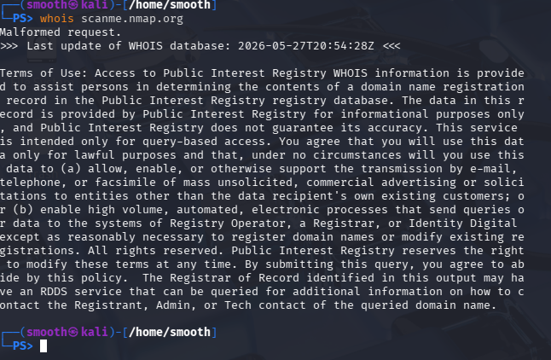

2.DNS Information(dig/nslookup)
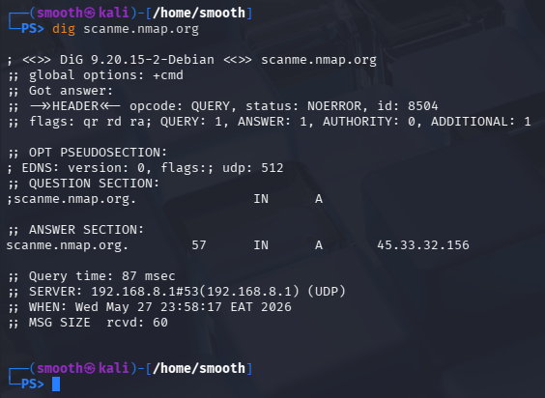
All about IP address and DNS records

Port Scanning

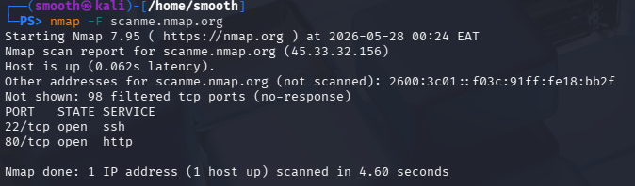

Port Scanning Results
A fast scan was conducted using Nmap against the target scanme.nmap.org.
Findings
The scan identified were:
- Port 22/tcp open (SSH service)
- Port 80/tcp open (HTTP service)
The target host was active and reachable with low latency. Most other ports were filtered and did not respond.
TASK 2

STEPS IN ETHICAL HACKING
1.Information gathering
A. Domain Registra

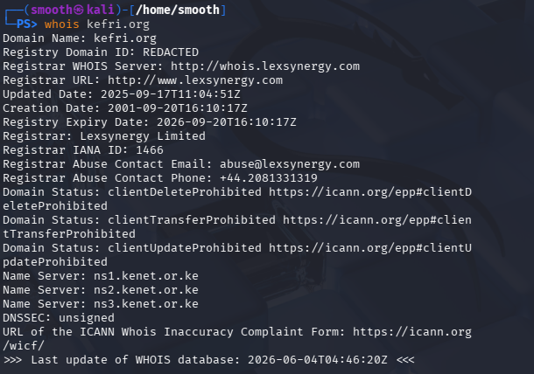

B.IP Adress

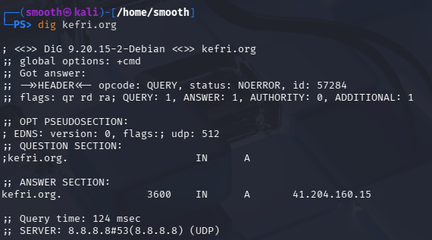
IP Adress: 41.204.160.15

C. Email patterns used

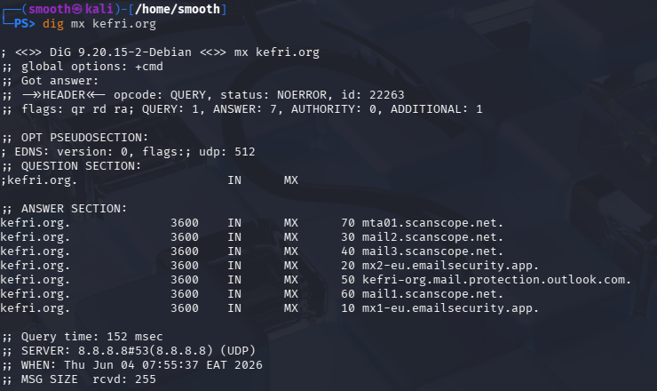
We had 7 answers and kefri.org uses Microsoft outlook for email services

D. Technologies used to run the website
This means that Apache is their webserver software running the website .403 forbidden means the sever understood the request but it refuse to provide the requested resource. This usually mean that directory browsing is disables/access restrictions are configured/the site blocks certain automated requests. This is usually done for security purposes.
SCANNING AND ENUMERATION
1.Scan open ports
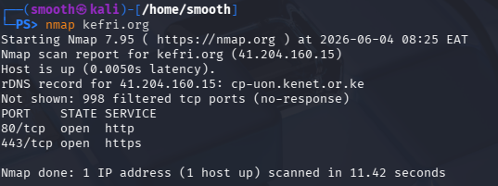
2. Detect running services
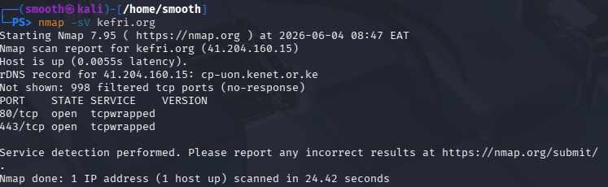
3.Identify the OS used
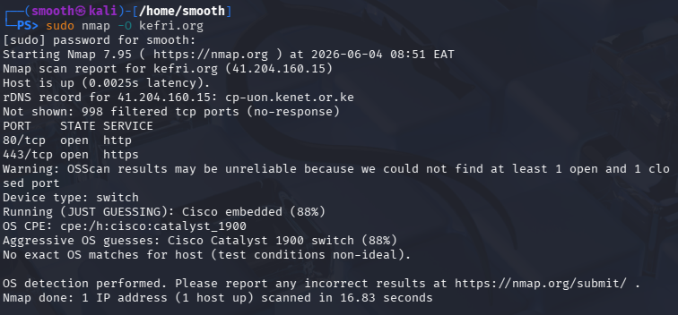
4.Enumerate users & service

